CVM Buildings and Grounds Q2 2024

- Structure that contains facility water, located at bottom of stairs at street level has cracking in the structure. Cracks should be cleaned out back to good structure. Internals should be examined for internal failure. If no failure, patch and repaint.
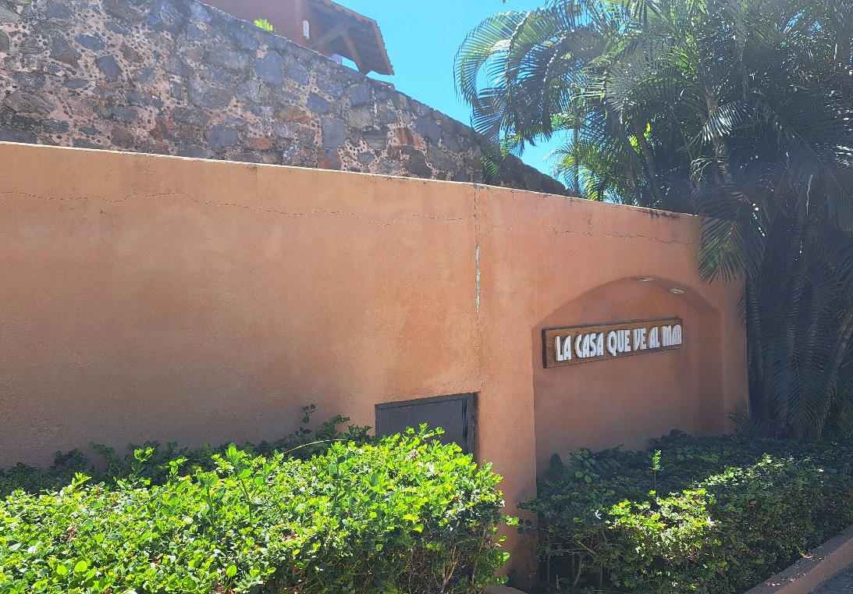

- The steel door into the same structure in never locked but it has a lock on it. Is there any concern that our water could get contaminated by someone with a grudge

- There is a rough hole in the street side of the Water Cistern’s structure that has had large amounts of water flowing out of it on many occasions. This water will run out onto the street and down the street a good distance. I have seen this on multiple occasions. This may be a normal process of flushing filters and nothing to be concerned with? But it may be a system failure and we are losing a good amount of water.

- The sidewalk area in front of our facility may be the only area at CVM that looks to be unmaintained a lot of the time. 50/50. Could use some weeding, trimming and garbage clean up from time to time

- This may already be in place: Suggest having Elevator service people identify “Critical Spares” and investigate advance purchase of such spares that Service Company keep and maintain for when needed. Or Keep spare in close proximity to location where spares would be need for rapid access.

- Suggest having Critical Spares for Potable water supply system. Pumps, Motors, Breakers, Floats, Controllers. Spares would be mounted to walls next to where they would be needed at. (this may be in place already but I have the impression it is not via, water system and elevator failures)

- There are 3-4 dead trees behind building B. I am not saying that all need to be removed as some birds prefer dead trees and dead trees provide bugs that eat on the decaying wood and provide food for other animals. This should be a decision by our gardening crew to remove or not and if so, how many?

- The grounds look amazing. Planters on landing by pools looks really nice

Below has nothing to do with the Buildings or Grounds.

- Web Site: There are no financial documents for 2024. An update on Electric Bill Savings as a result of Solar Panels would be beneficial.
- Owners would like to see 2024 calculation of dues list in on line documents
- Last Important Documents posted on line was 2022
- Last water testing report posted on line was Jan 2021.
- Last Buildings and grounds committee report posted on line was Feb. 2019.
- Rental Rules should be reviewed and updated if needed. The Rules should be posted during High Season or Owners should make sure there is a copy in their units. Suggest, RULE 1: CVM wants everyone to have a good time and by complying with the below rules, we hope that all visitors and owners will have a wonderful time and want to return.
- The Reserve Study of 2019 is very good and should be reviewed again. Owners with elevator access should take special notice of this report and prepare for the pending upgrade. The 1,000,000p estimates may have changed since 2019.

